Bass Clef Major Scales

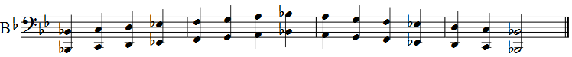
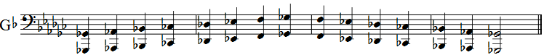

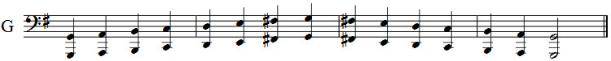
Bass Clef Enharmonic Major Scales

