Bass Clef Natural Minor Scales

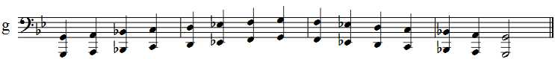
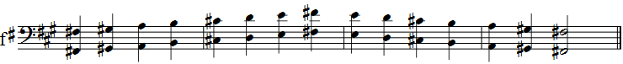

Bass Clef Enharmonic Natural Minor Scale

