7th-Grade Study Guide #2

- The five basic musicianship skills are Tone, Intonation, Technique, Rhythm, and Interpretation.

- The four essential elements of a good tone are Embouchure, Breath Support, Good Equipment, and Concept.

- To find concert pitch, instruments built in concert pitch just play the pitch asked for; Bb instruments transpose up two half-steps; Eb instruments transpose down three half-steps; F instruments transpose up seven half-steps.

- Know which note to play for concert Bb, Eb, Ab, and Db.

- Know the meaning of the words and symbols in book 1. *

- Deliberately changing the pitch is called humoring.

- Three ways to change the pitch are tighten or loosen the embouchure, change the length of the instrument, and use a different fingering.

- A good way to learn to hold a steady pitch is by working with a strobe.

- A good way to learn to recognize and eliminate beats is by working with a tuner.

- Pitch follows mercury. If it’s cold, you’ll be flat. If it’s hot, you’ll be sharp.

- A good rule to follow when humoring is to move slowly.

- Know how to tongue properly.
  - Flutes and brass touch the roof of your mouth with tip of tongue.
  - Reeds touch tip of reed with tip of tongue.
  - No jaw movement
  - On a series of short notes, blow as if you were playing one long note.

- The top number of a time signature indicates how many beats per measure.

- The bottom number of a time signature indicates what kind of note gets one count.

- x is a double sharp. It raises the pitch two half-steps.

- bb is a double flat. It lowers the pitch two half-steps.

- Be able to count and recognize the following rhythm patterns.

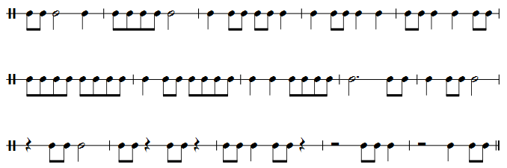

- Be able to diagram the following rhythm patterns:

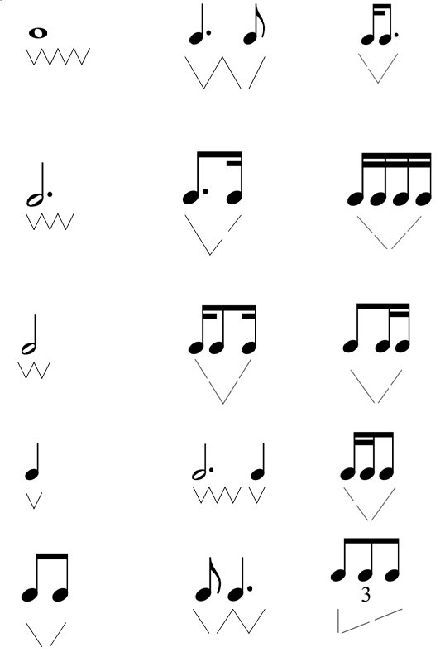

* Some of the band method books I used had a list of terms and symbols at the back of the book. Some did not. Since I always required the beginners to have a Note Speller and it had a similar list on the last page, I used that for this test. A copy was attached to this study guide. For copyright reasons it is not attached here.

