Percussion Study Guide #2

- The five basic musicianship skills are Tone, Intonation, Technique, Rhythm, and Interpretation.

- When you strike any percussion instrument, think of pulling the sound out, not pounding the sound in.

  - Know which note to play for concert Bb, Eb, Ab, and Db.

  - Know the meaning of the words and symbols in book 1.

  - The two approaches to rolls are (1) open-closed-open and (2) preparatory stokes.

  - The objective or goal of rolls is to produce a sustained sound. The following are essential elements to "silky smooth" rolls:
-Use a matched set of sticks.
-Strike the head in the same spot with each stick.
-Make the bounce stroke sound the same as the swing stoke.
-Maintain an even alternation of hands.

  - To determine the preparatory stokes for a given roll, divide by two and round up.
Example: 5-stoke roll
5 divided by 2 is 2 1/2
2 1/2 rounds up to 3
A 5-stroke roll has 3 preparatory stokes

  - The tempo is what determines which rolls you use.

  - The top number of a time signature indicates how many beats per measure.

  - The bottom number of a time signature indicates what kind of notes receives one count.

  - x is a double sharp. It raises the pitch two half steps.

  - bb is a double flat. It lowers the pitch two half steps.

  - Be able to count and recognize the following rhythm patterns: 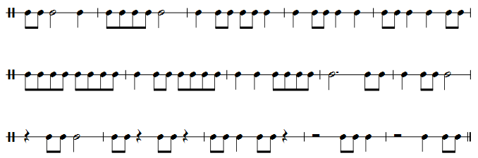

  - Be able to diagram the following rhythm patterns:

