Treble Clef Major Scales
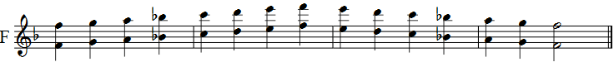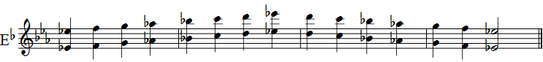

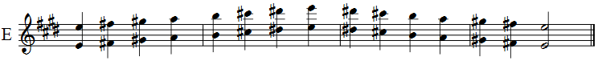

Treble Clef Enharmonic Major Scales

