Treble Clef Natural Minor Scales

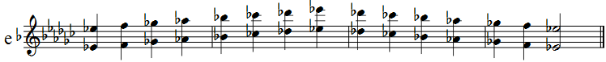
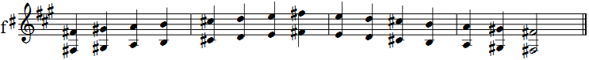
Treble Clef Enharmonic Natural Minor Scales

