7TH GRADE - TEST #1

DO NOT WRITE ON THIS TEST
WRITE ONLY ON YOUR ANSWER SHEET

1. One of the five basic musicianship skills is
a. balance b. technique c. precision d. phrasing

2. One of the five basic musicianship skills is
a. embouchure b. tonguing c. rhythm d. dynamics

3. One of the five basic musicianship skills is
a. interpretation b. tempo c. nuance d. style

4. One of the five basic musicianship skills is
a. tone b. articulation c. breath support d. posture

5. One of the five basic musicianship skills is
a. concept b. staccato c. attack-sustain-release
d. intonation

6. Which one of the following is one of the essential elements of a good tone?
a. embouchure b. rhythm c. speedy tongue d. curved fingers

7. Which one of the following is one of the essential elements of a good tone?
a. phrasing b. precision c. articulation d. breath support

8. Which one of the following is one of the essential elements of a good tone?
a. dynamics b. good equipment c. pitch d. none of these

9. Which one of the following is one of the essential elements of a good tone?
a. precept b. except c. concept d. intercept

IDENTIFY THE IMPORTANT ASPECTS OF A GOOD EMBOUCHURE FOR YOUR INSTRUMENT. DRUMMERS IDENTIFY PROPER PLAYING POSITION.

BRASS
10. a. peach-stone chin b. flat chin c. round chin d. double chin

11. a. loose corners b. puffed cheeks c. tight corners d. open corners

12. a. no pressure b. little pressure c. medium pressure
d. much pressure

FLUTES
10. a. peach-stone chin b. flat chin c. round chin d. double chin

11. a. loose corners b. puffed cheeks c. tight corners d. open corners

12. a. very small aperture b. medium-size aperture c. large aperture
d. very large aperture

SINGLE REED INSTRUMENTS
10. a. peach-stone chin b. flat chin c. round chin d. double chin

11. a. loose corners b. puffed cheeks c. tight corners d. open corners

12. a. lips tight against teeth b. lips in “whistle” position
c. loose lips d. smile-like lips

DOUBLE REED INSTRUMENTS
10. a. peach-stone chin b. flat chin c. round chin d. double chin

11. a. loose corners b. puffed cheeks c. tight corners d. open corners

12. a. both lips cover teeth slightly b. lips in whistle formation
c. lips in pucker position d. upper teeth on top of reed

PERCUSSION
10. a. stiff wrists b. loose wrists c. bent knees d. cocked head

11. a. stick is held between the middle knuckles of the thumb and index finger
b. stick is held in the crotch between the thumb and the index finger
c. stick is held between the first knuckles of the thumb and the index finger
d. grasp stick tightly with all fingers

12. a. place drum 2 inches below waist level
b. place drum 6 inches below waist level
c. place drum 2 feet below waist level
d. place drum directly on the floor

EVERYONE
13. Proper posture and playing position are described as
a. resting your arms on your thighs
b. crossed legs and a slight slump in the back
c. sitting as if you were standing from the waist up
d. none of these

14. What do your shoulders do when you are breathing properly?
a. raise slightly
b. slump forward
c. stay down and relaxed
d. raise up and tighten

15. Good breath support consists of what kind of breathing?
a. shoulder b. shallow c. abdominal d. none of these

16. Good equipment refers to
a. reeds b. mouthpieces c. valves d. all of these

17. Good equipment refers to
a. pads and springs
b. drum heads and sticks
c. clean, well-oiled instruments
d. all of these

l8. Good equipment refers to
a. car b. truck c. Xerox d. none of these

19. Good equipment refers to
a. properly working tuning slides
b. the absence of dents and cracks in an instrument
c. properly seated pads
d. all of these

20. A good way to learn how your instrument should sound is to
a. play so loud you can’t hear anyone else
b. take private lessons from someone who plays well
c. listen to an older brother or sister who dropped out of band in the ninth grade d. none of these

21. A good way to learn how your instrument should sound is to
a. play someone else’s instrument
b. listen to acid rock
c. listen to recordings of professional instrumentalists
d. none of these

22. One of the steps to playing in tune is
a. attack just before the downbeat
b. hold a steady pitch
c. tongue with great precision
d. Attack-Sustain-Release

23. One of the steps to playing in tune is
a. recognize the conductor
b. recognize the music
c. recognize the composer
d. recognize the beats

24. One of the steps to playing in tune is
a. eliminate the conductor
b. eliminate the music
c. eliminate the beats
d. eliminate the composer

25. To produce a steady pitch you must produce
a. a strong right arm
b. a steady, even flow of air
c. short choppy spurts of air
d. none of these

26. When two notes of slightly different pitches are played together we hear
a. beats b. nothing c. good intonation d. harmony

27. When two of the same pitches are played together it sounds
a. good b. in tune c. like one d. all of these

28. Which word describes the mental picture we need to develop to have good tone?
a. dream b. vision c. concept d. thought

29. The slogan for playing in tune is
a. Sound Like One
b. The more beats the better
c. If you hear beats, suck in
d. long live the conductor!

30. The key to playing in tune is
a. very small
b. hard to find
c. play so soft you can’t be heard
d. Listen, Listen, Listen

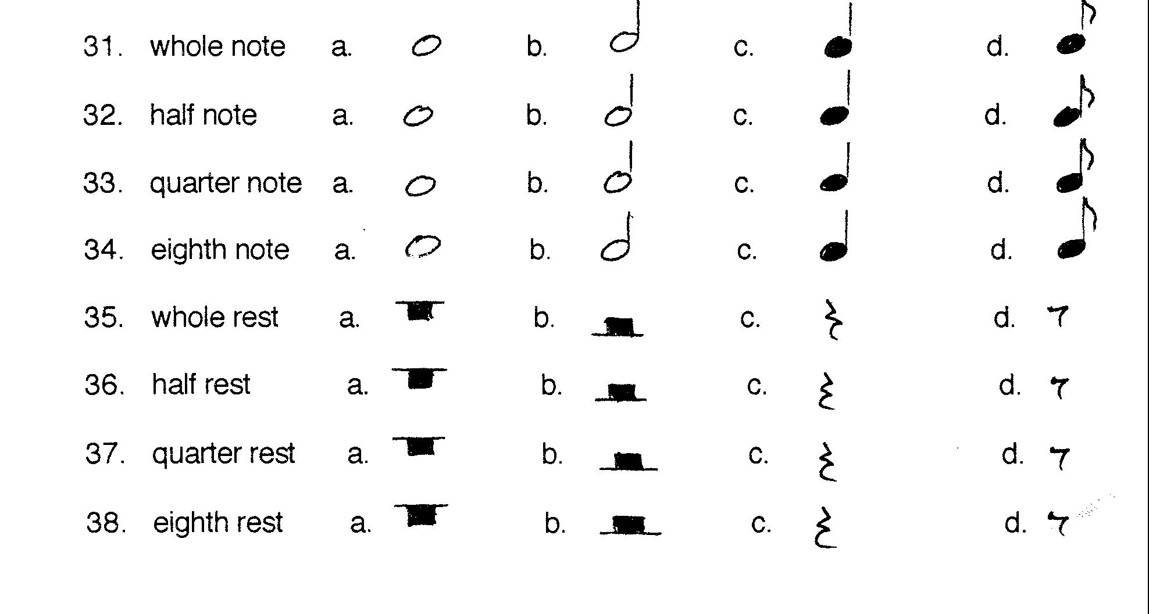
39. Good intonation is playing
a. by yourself b. in tune c. out of tune d. loudly

40. Poor intonation is playing
a. by yourself b. in tune c. out of tune d. loudly

41. Your ability to tongue and finger with good precision is called
a. coordination b. musicianship c. rhythm d. technique

42. Tonguing and slurring properly refer to a. technique b. precision
c. articulation d. interpretation

43. Which word refers to volume? a. tempo b. dynamics
c. intonation d. tone

44. Which word means soft? a. Charmin b. mezzo piano
c. piano d. forte

45. Which word means medium soft?
a. mezzo forte b. mezzo piano c. piano d. M. D.

46. Which word means medium loud?
a. mezzo forte b. mezzo piano c. forte d. fortissimo

47. Which word means loud?
a. forte b. fortissimo c. piano d. pianissimo

48. Which word means very loud?
a. forte b. piano c. fortissimo d. pianissimo

49. Which word means very soft?
a. forte b. piano c. fortissimo d. pianissimo

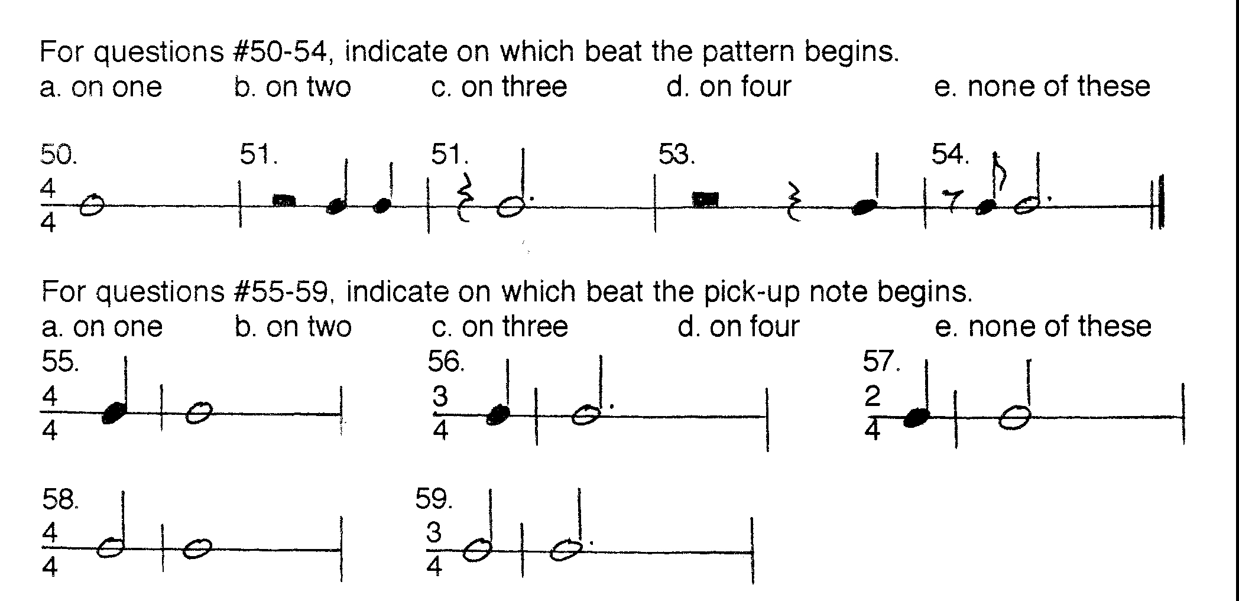
60. When should you arrive at a concert?
a. early b. on time c. late d. none of these

61. If you are late or had to leave for some reason, when should you enter or reenter the concert hall?
a. when you feel like it b. during a loud section of music c. never d. at the end of a given piece or section

62. When should you whistle, scream or yell?
a. when you feel like it
b. when you are musically moved to tears
c. never
d. when you can’t clap any louder

63. Should you applaud every time an orchestra stops playing?
a. yes b. no

64. Should you applaud when the conductor or soloist comes on stage?
a. yes b. no

65. Should you applaud after improvised solos in a jazz concert?
a. yes b. no

66. How can you emphasize the sincerity of your applause?
a. applaud louder b. applaud longer c. stand up d. all of these

67. When does a performance deserve a standing ovation?
a. when you can’t stand to sit any longer
b. when you know the performer personally
c. when everyone else stands up
d. when you feel the piece couldn’t possibly be performed any better

68. When is it permissible to talk during a performance?
a. when you’ve got something important to say
b. always
c. never
d. none of these

69. How should you dress for a concert?
a. poorly b. overly c. strangely d. appropriately

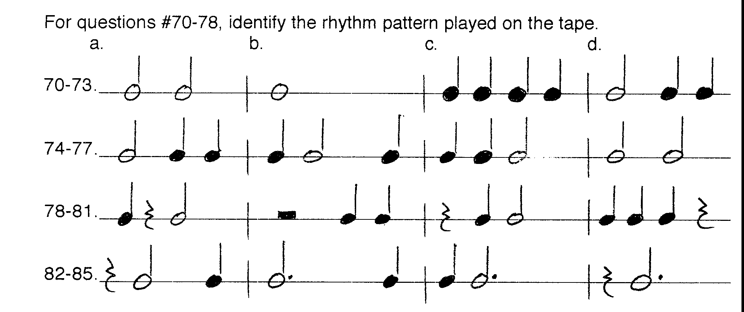For questions #86-95, you will hear two pitches. Listen carefully, then indicate whether
the second pitch is lower, higher, or the same as the first.
86-95 a. lower b. higher c. same

For questions #96-100, you will hear an instrument played with good and poor tone. Indicate which tone sounds better.
96-100 a. first b. second

