8TH-GRADE - TEST #2

DO NOT WRITE ON THIS TEST

WRITE ONLY ON YOUR ANSWER SHEET

1. One of the five basic musicianship skills is
a. balance b. technique c. precision d. phrasing

2. One of the five basic musicianship skills is
a. embouchure b. tonguing c. rhythm d. dynamics

3. One of the five basic musicianship skills is
a. interpretation b. tempo c. nuance d. style

4. One of the five basic musicianship skills is
a. tone b. articulation c. breath support d. posture

5. One of the five basic musicianship skills is
a. concept b, staccato c. sustain d. intonation

For questions #6-9 indicate which note you play for the given concert pitch. Answer for your instrument only.

FOR F INSTRUMENTS ONLY
6. Concert Gb a. F b. A c. E d. Db

7. Concert B a. F b. B c. Bb d. F#

8. Concert E a. E b. Eb c. G d. B

9. Concert A a. C b. Bb c. F d. E

FOR C INSTRUMENTS ONLY
6. Concert Gb a. Bb b. D c. Ab d. Gb

7. Concert B a. E b. D c. Eb d. B

8. Concert E a. Bb b. Ab c. C d. E

9. Concert A a. F b. C c. Ab d. A

FOR Bb INSTRUMENTS ONLY
6. Concert Gb a. C b. E c. B d. Ab

7. Concert B a. B b. Eb c. F d. C#

8. Concert E a. Ab b. Bb c. D d. F#

9. Concert A a. G b. Cb c. E d. B

FOR Eb INSTRUMENTS ONLY
6. Concert Gb a. G b. B c. Db d. Eb

7. Concert B a. Eb b. Gb c. C d. G#

8. Concert E a. C b. F c. A d. C#

9. Concert A a. D b. Eb c. Ab d. F#

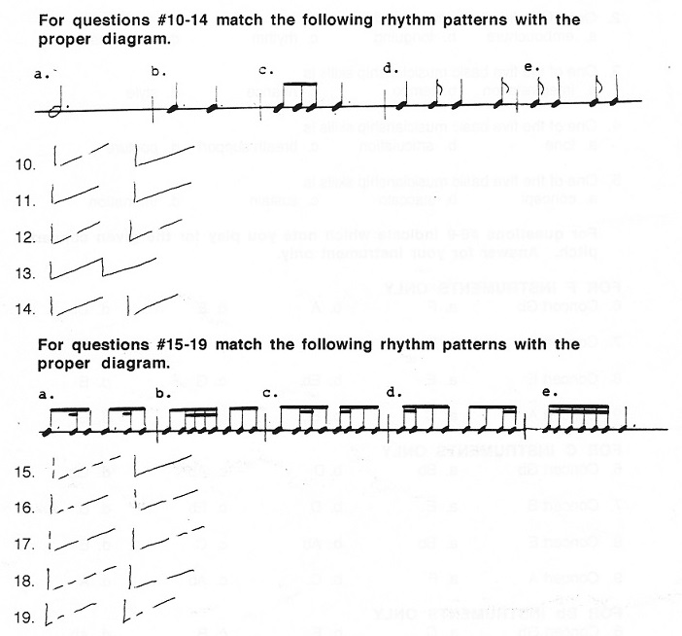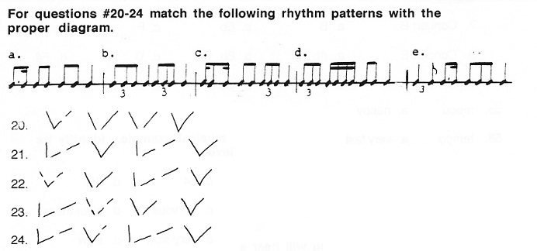
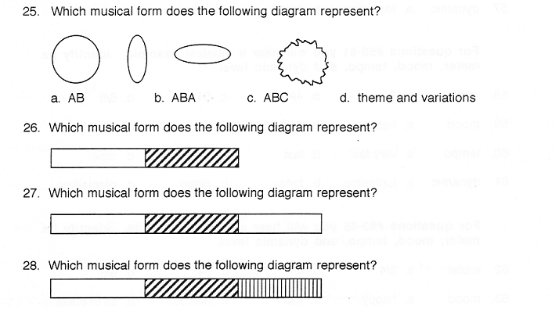

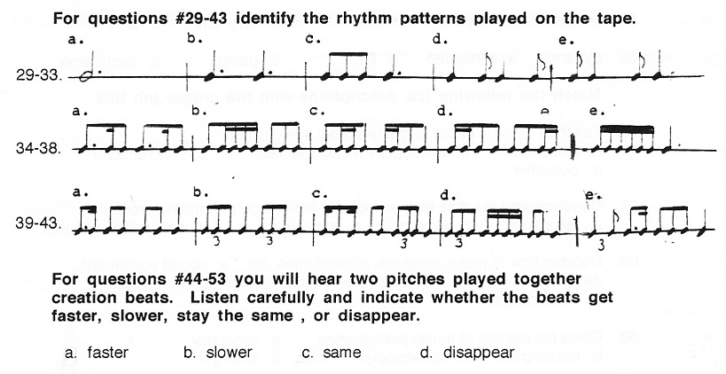
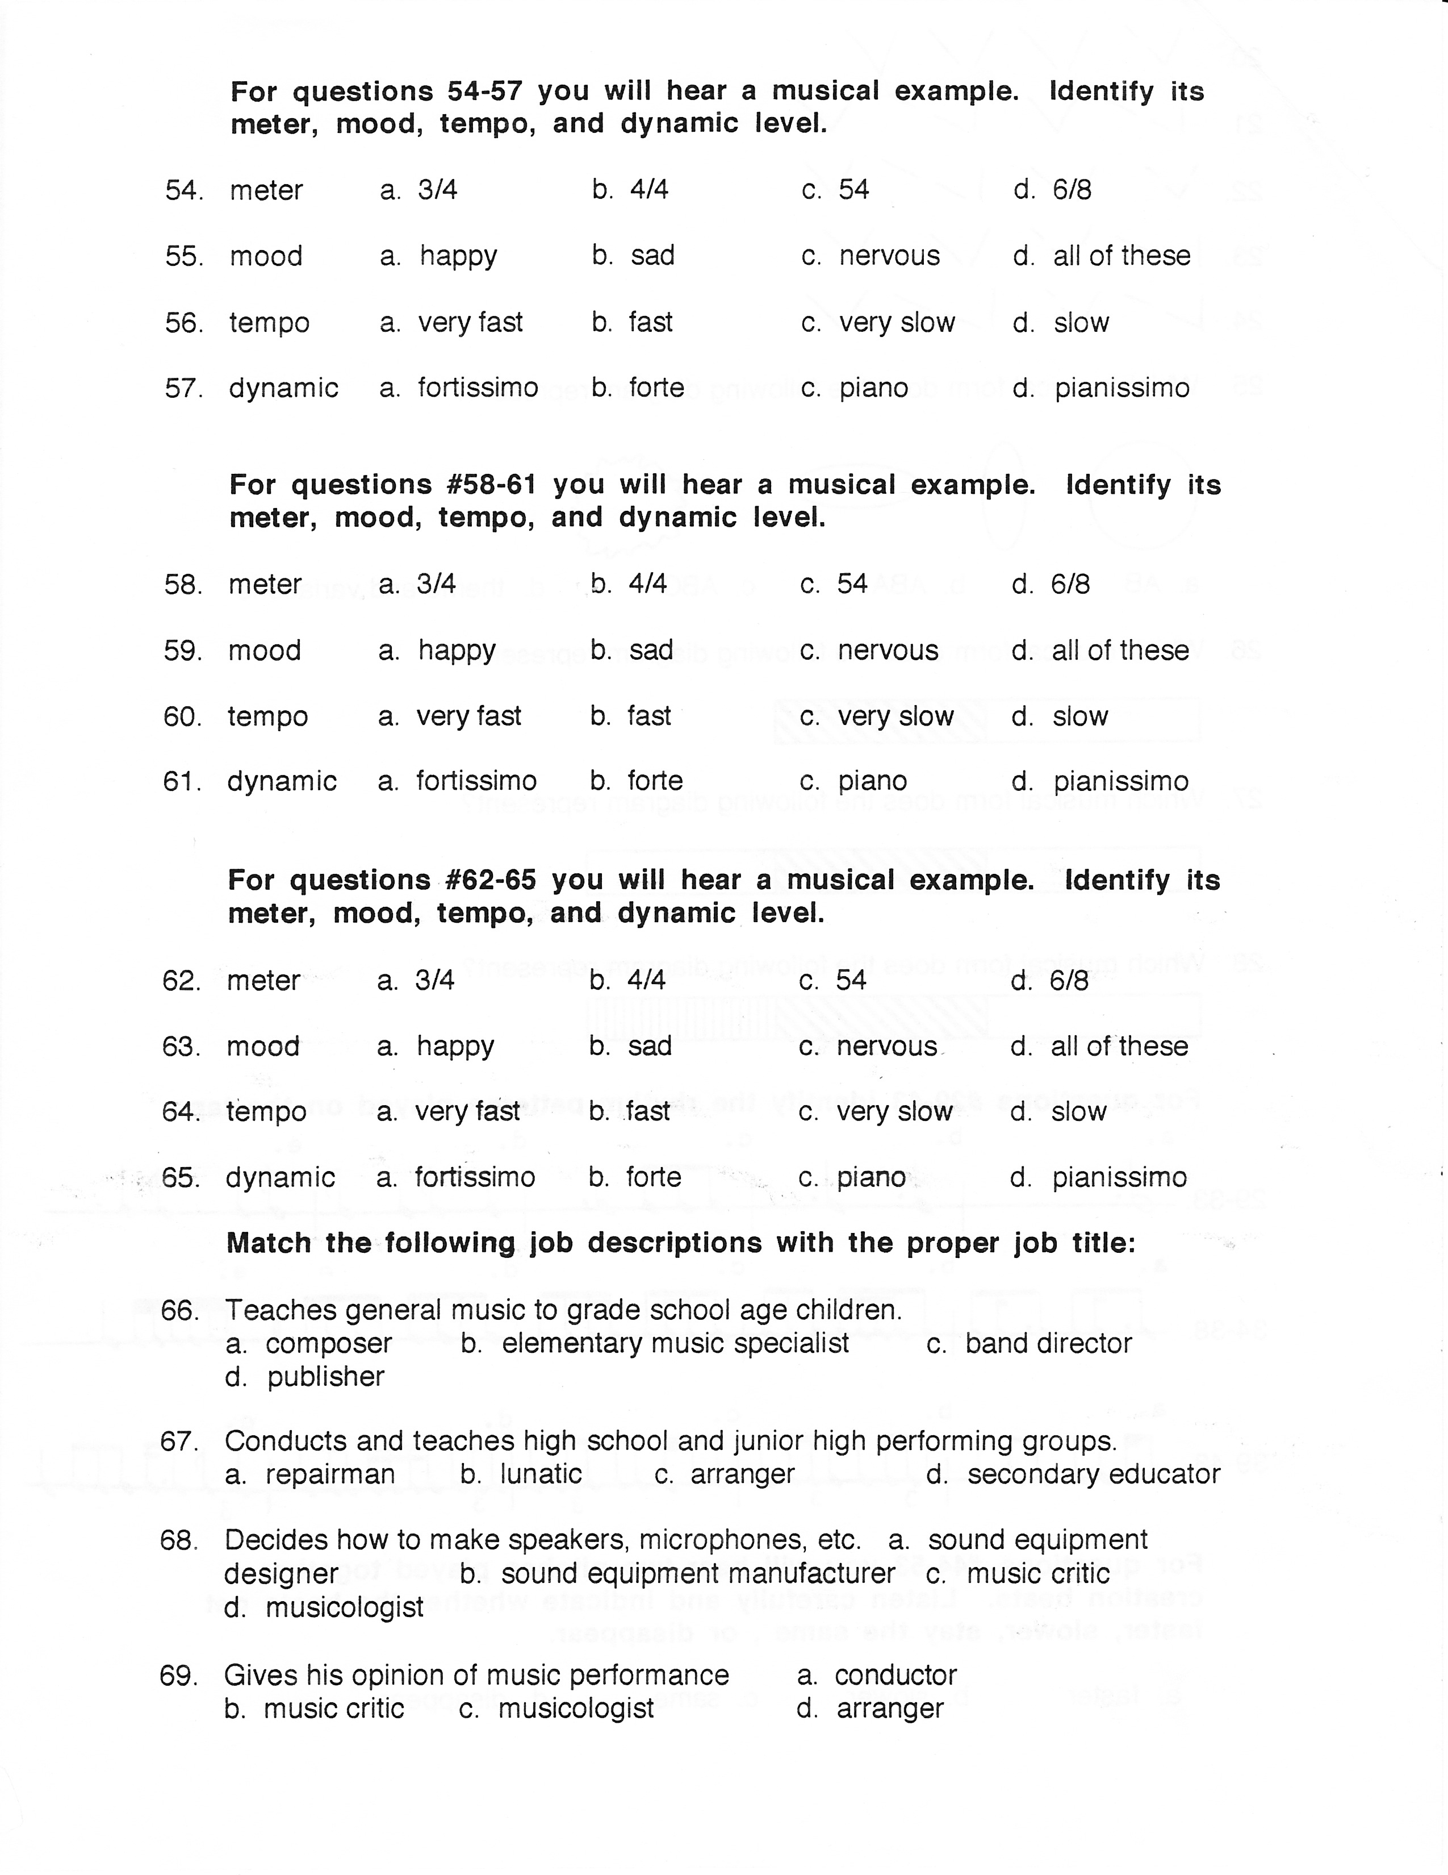

70. Works with sound waves and construction
a. acoustical engineer b. composer c. conductor d. therapist

71. Music researcher
a. engraver b. copyist c. publisher d. musicologist

72. Mixes and balances sounds
a. recording technician b. composer c. repairman d. music critic

73. Adapts, modifies, and embellishes compositions
a. copyist b. engraver c. arranger d. composer

74. Directs professional performing groups
a. conductor b. arranger c. music engineer d. composer

75. Rewrites music by hand in ink
a. engraver b. copyist c. publisher d. arranger

76. Music artist; draws in slurs, beams, and crescendo marks, etc.
a. engraver b. copyist c. publisher d. arranger

77. Writes and creates new music
a. arranger b. composer c. musicologist d. copyist

78. Uses music to cure illness and disease
a. Therapist b. repairman c. engineer d. technician

79. Tunes and repairs pianos and organs
a. piano and organ tuner b. soloist c. symphony member d. salesman

80. Recording artist; is expected to play it right the first time
a. musicologist b. studio musician c. college professor d. band director

81. When should you arrive at a concert?
a. early b. on time c. late d. none of these

82. If you were late or had to leave for some reason, when should you enter or reenter the concert hall?
a. when you feel like it
b. during a loud section of music
c. never
d. at the end of a given piece of section

83. When should you whistle, scream , of yell?
a. when you feel like it
b. when you are musically moved to tears
c. never
d. when you can’t clap any louder

84. Should you applaud every time an orchestra stops playing?
a. yes b. no

85. Should you applaud when the conductor of soloist comes on stage?
a. yes b. no

86. Should you applaud after improvised solos is a jazz concert?
a. yes b. no

87. How can you emphasize the sincerity of your applause?
a. applaud louder
b. applaud longer
c. stand up
d. all of these

88. When would a performance deserve a standing ovation?
a. when you can’t stand to sit any longer
b. when you personally know the performer
c. when everybody else stands up
d. when you feel the piece couldn't possibly be performed any better.

89. When is it permissible to talk during a performance?
a. always
b. when you’ve got something important to say
c. never
d. none of these

90. The correct spelling of rhythm is
a. rhythum b. rhythem c. rithem d. rhythm

91. One of the two types of meter is
a. double b. triple c. home run d. foul

92. One of the two types of meter is
a. duple b. treble c. quadruple d. syncopation

93. A quarter note usually gets one count in ____________ meter.
a. duple b. triple c. quadruple d. none of these

94. A dotted quarter note usually gets one count in ____________ meter.
a. duple b. triple c. quadruple d. none of these

95. The bottom number of a duple meter time signature is usually a/an
a. 2. b. 3 c. 4 d. 8

96. The bottom number of a triple meter time signature is usually a/an
a. 2. b. 3 c. 4 d. 8

97. How do we count 16th notes in duple meter?
a. one ta te ta
b. one ta la ta le ta
c. one e and a
d. one te ta te
e. one la ta le ta lo

98. How do we count 16th notes in triple meter?
a. one ta te ta
b. one ta la ta le ta
c. one e and a
d. one te ta te
e. one la ta le ta lo

99. The most important rhythmic decision to make before you play a piece is
a. how fast to play
b. swing, rock, Latin, or ballad
c. duple or triple meter
d. style

100. An easy way to determine the meter of a piece is to look at
a. the composer’s name
b. your stand partner’s feet
c. the key signature
d. the top number of the time signature
e. the bottom number of the time signature

